Nama : Anita Siagian

Tugas

Lakukanlah pengelolaan kegiatan pengujian menggunakan Jira dan TestRail untuk :

|  |  |
| --- | --- |
| **Portal Berita** | **Toko Online** |
| 3 Halaman | 3 Halaman |
| 3 Test Case untuk Tiap Halaman | 3 Test Case untuk Tiap Halaman |

Jawab :

Nama Project : BIGTASK1_Anita Siagian_idntimes

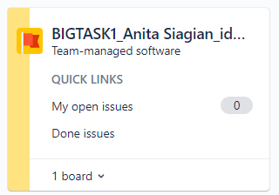

Halaman yang akan diuji adalah : IDNTimes

1. Test Case untuk Halaman Login

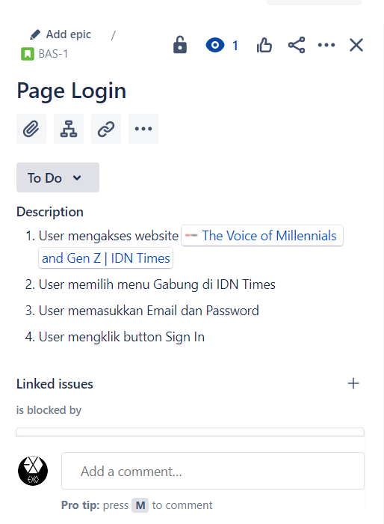

* Test Case 1 : User input valid email and password

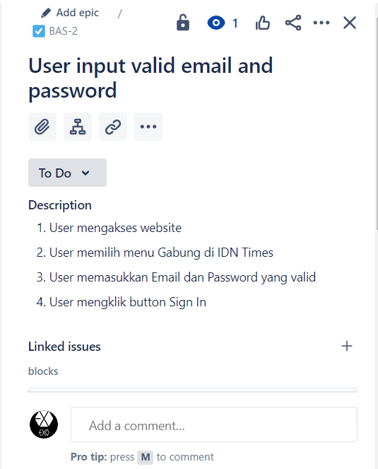

* Test Case 2 : User input invalid email and password

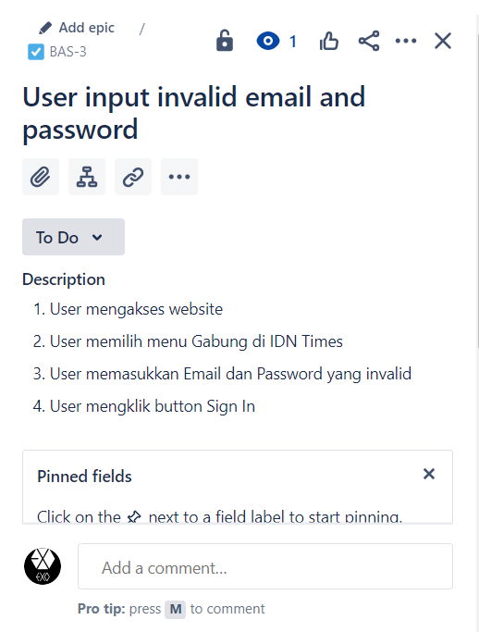

* Test Case 3 : User input valid email in Lupa Password

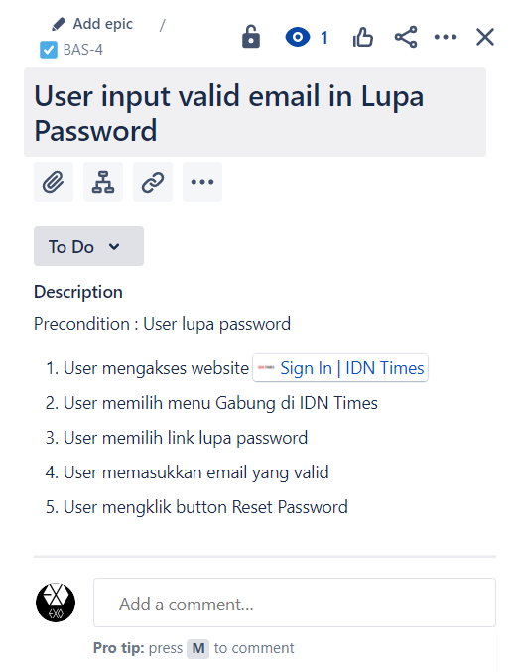

1. Test Case untuk Halaman Sign Up

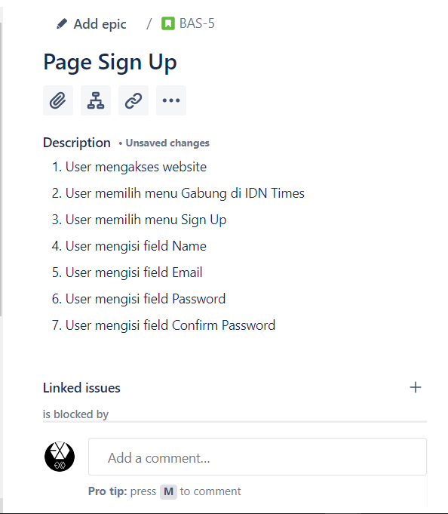

* Test Case 1 : User Input Valid Email in Page Sign Up

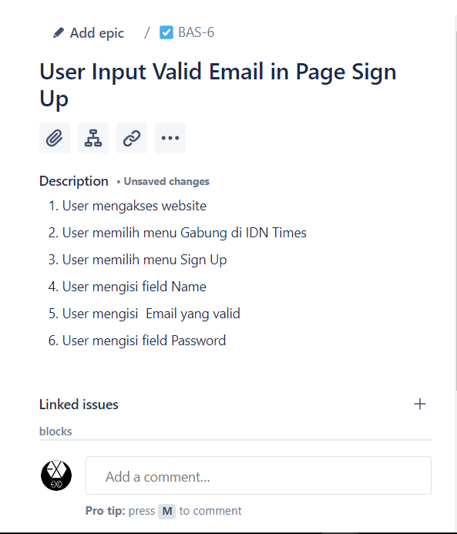

* Test Case 2 : User Input Invalid Email in Page Sign Up

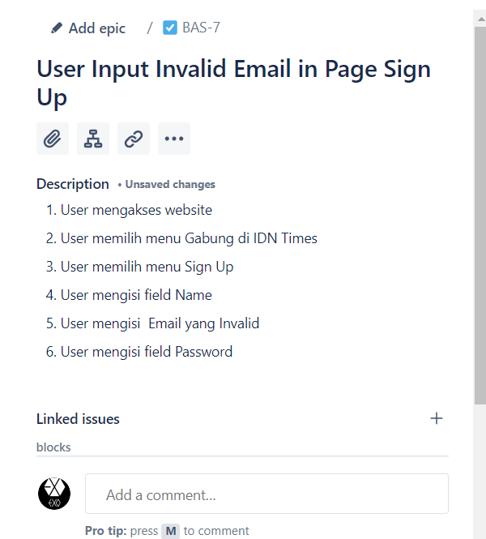

* Test Case 3 : User input the same Password and Confirm Password

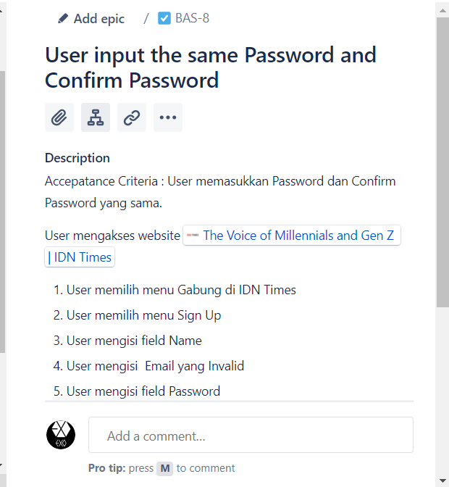

1. Test Case untuk Halaman Page Search

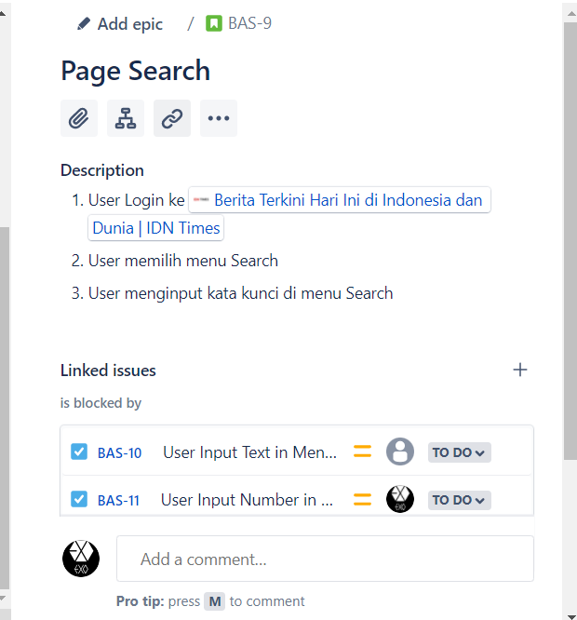

* Test Case 1 : User Input Text in Menu Search

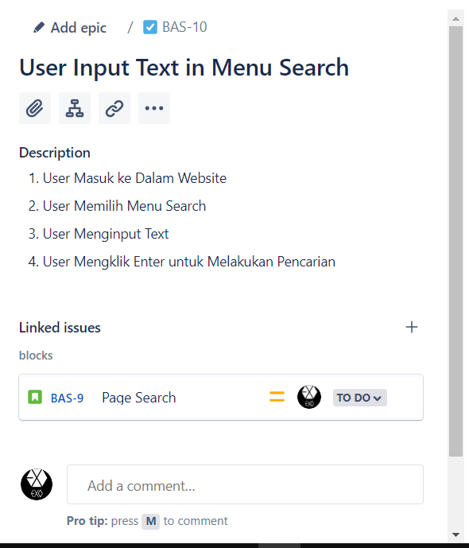

* Test Case 2 : User Number Character in Menu Search

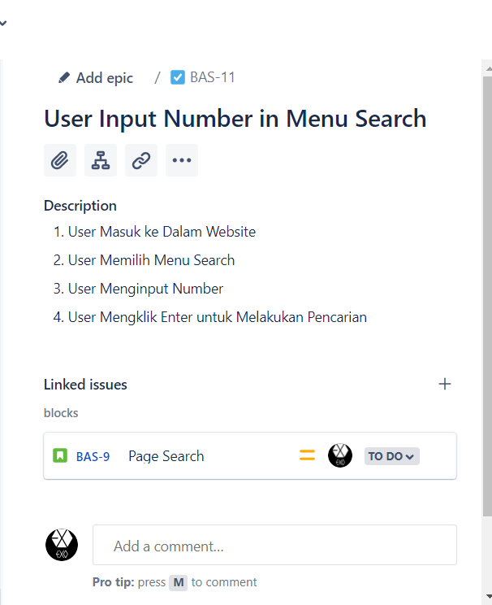

* Test Case 3 : : User Input Character in Menu Search

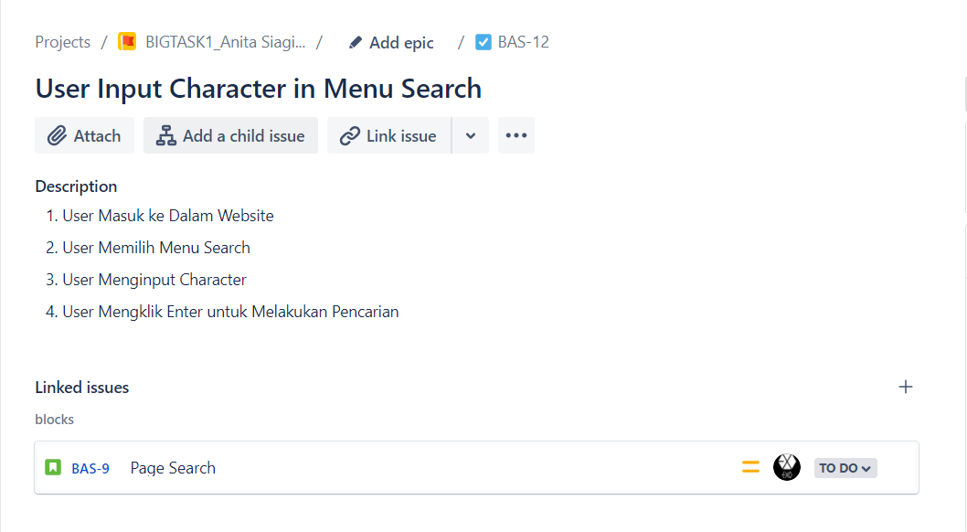

Board BIGTASK1_Anita Siagian_idntimes

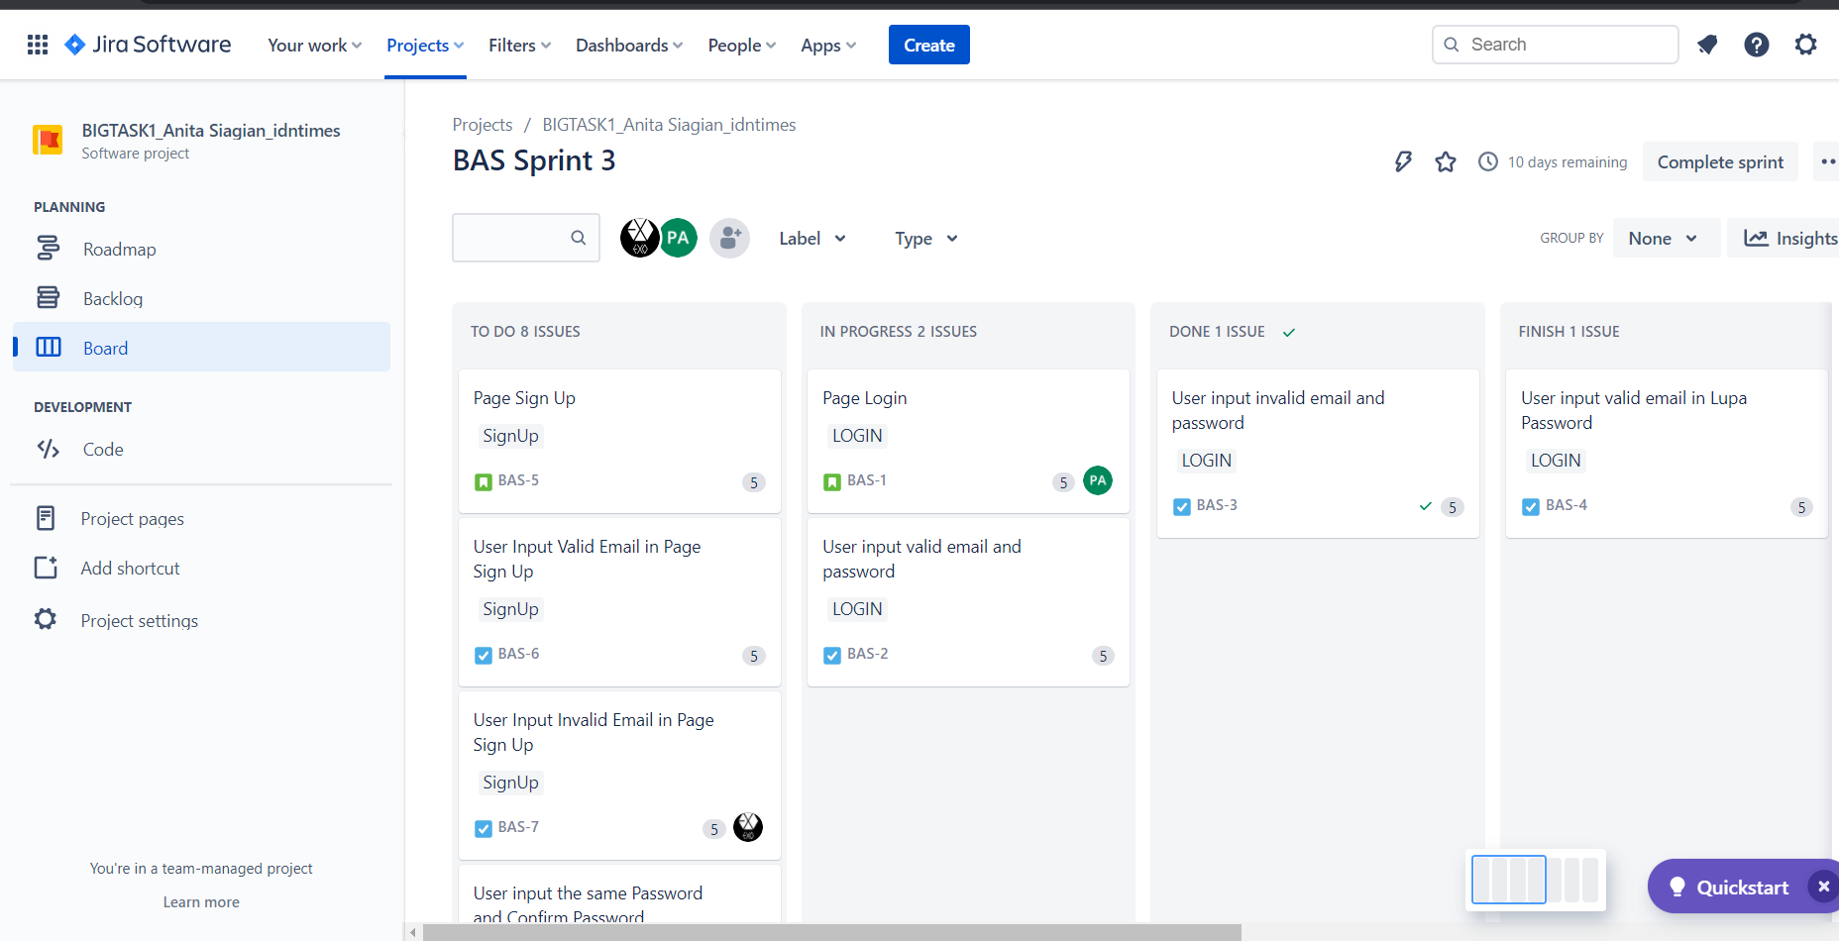

Test Rail

1. Page Login

Test Case 1 : User input valid email and password

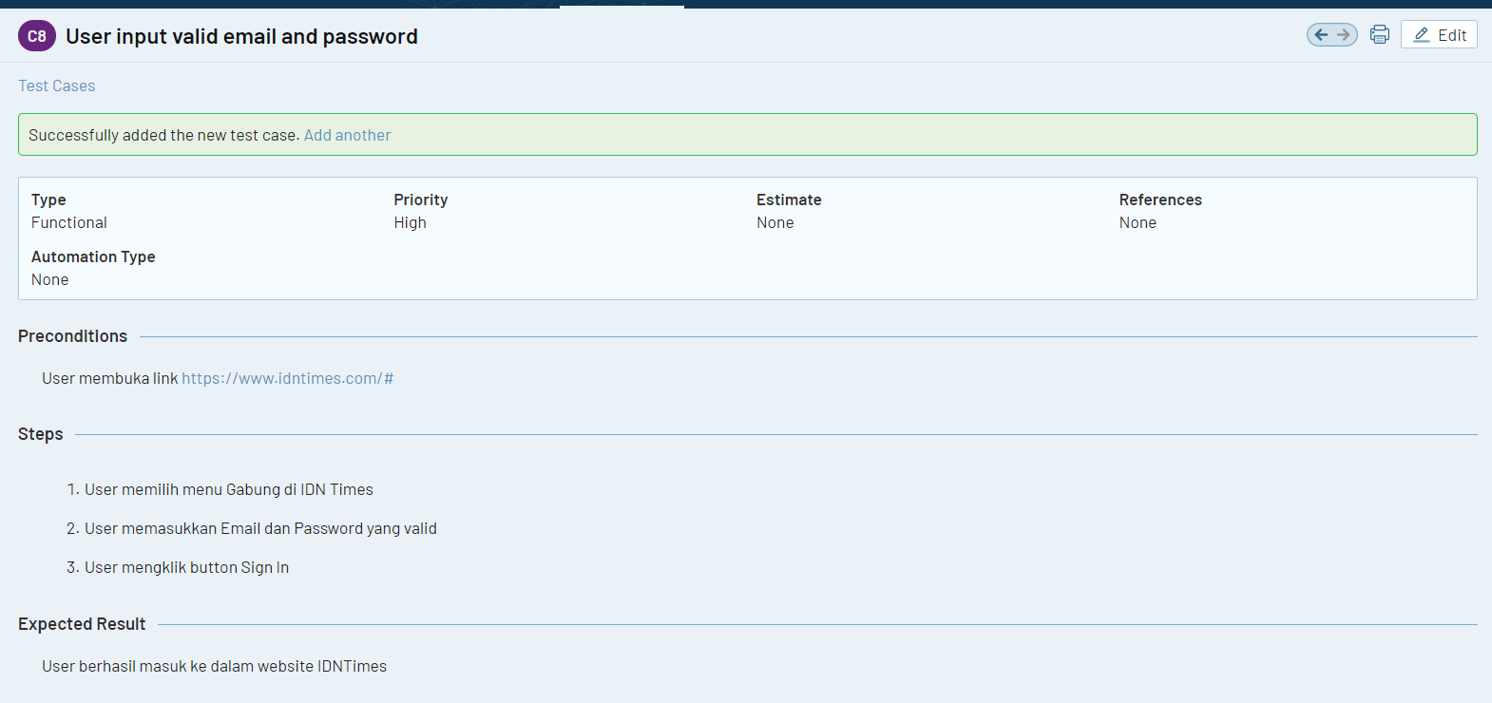

Test Case 2 : User input invalid email and password

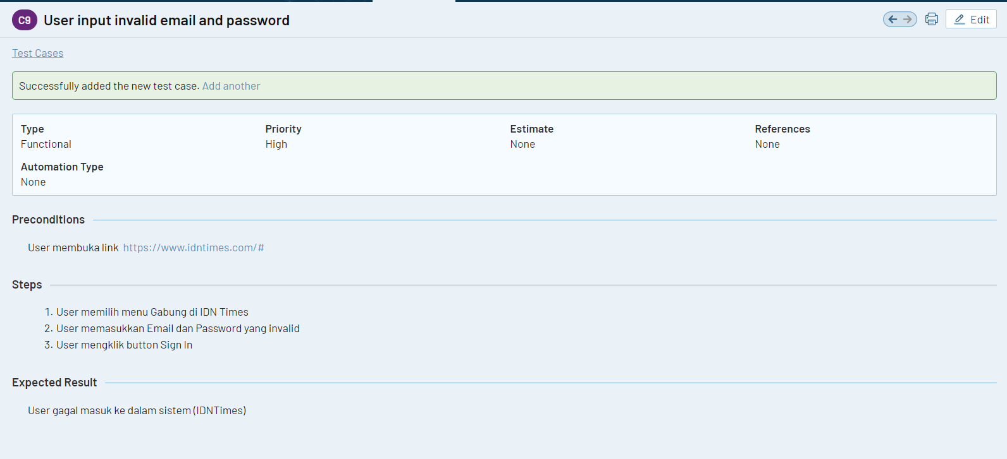

Test Case 3 : User input valid email in Lupa Password

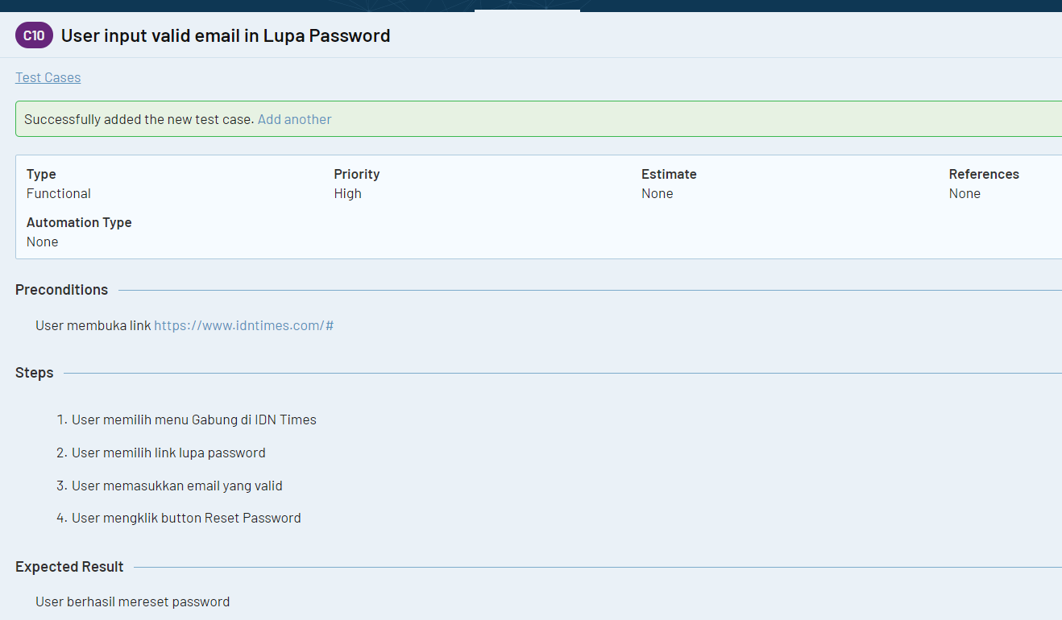

Start Milestone

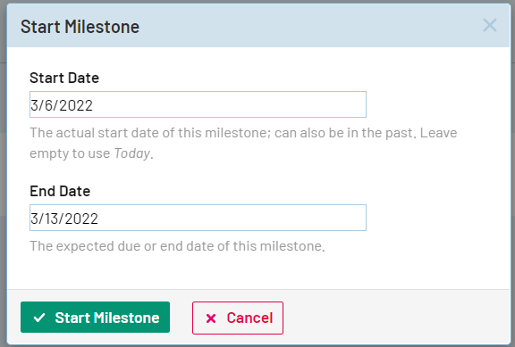

Test Run For Page Login

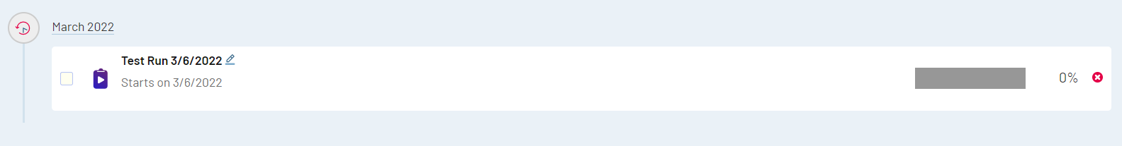

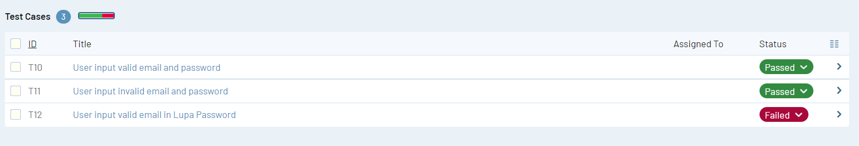

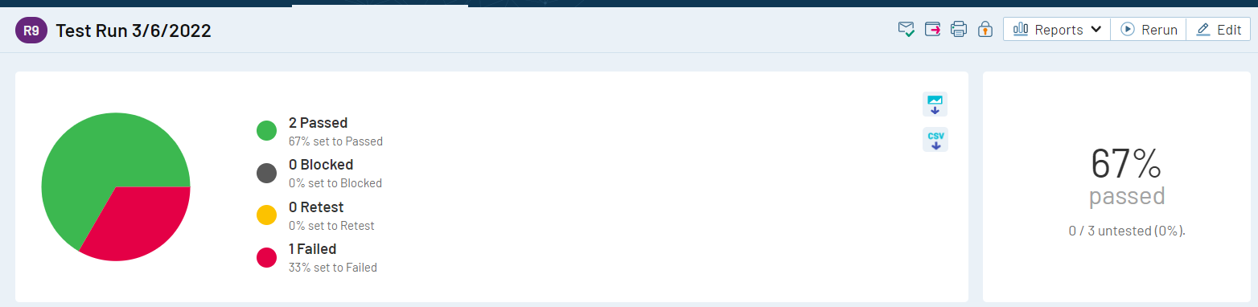

Page Sign Up

Test Case 1 : User Input Valid Email in Page Sign Up

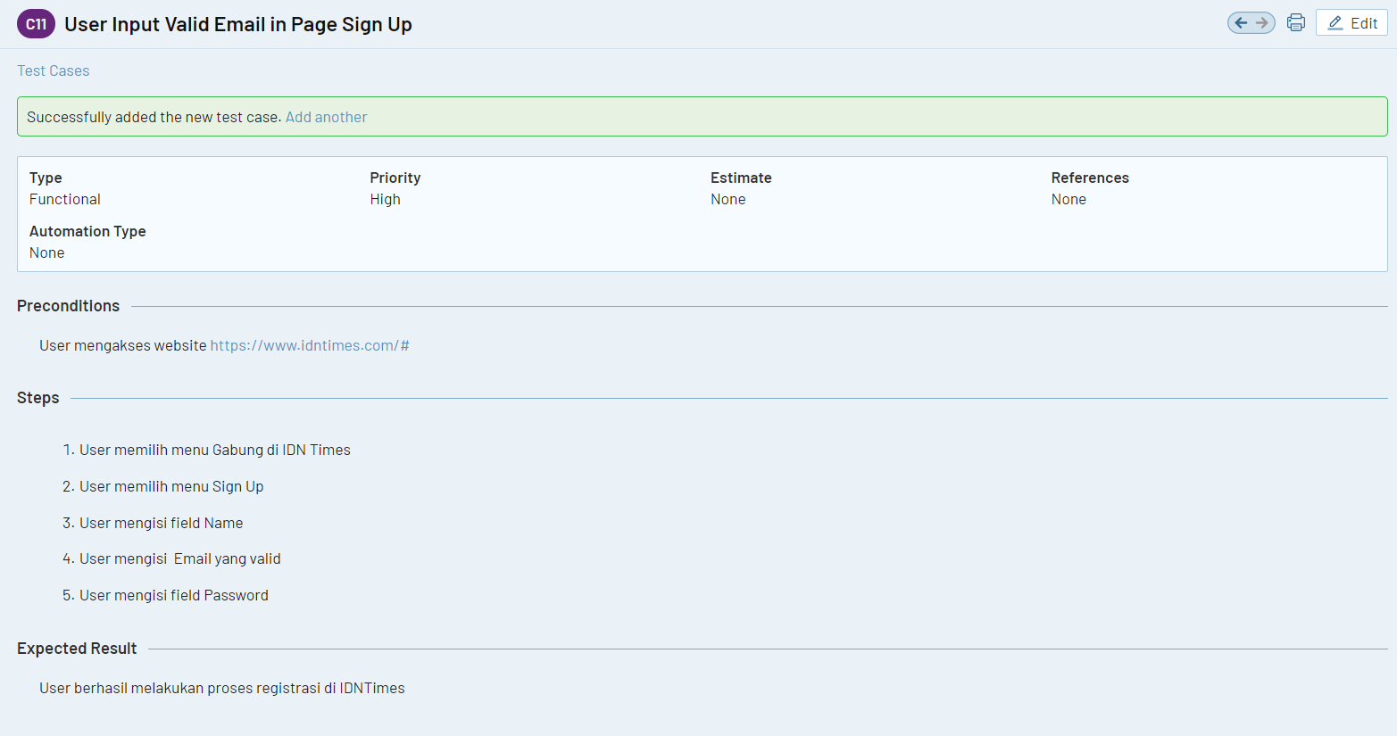

Test Case 2 : User Input Invalid Email in Page Sign Up

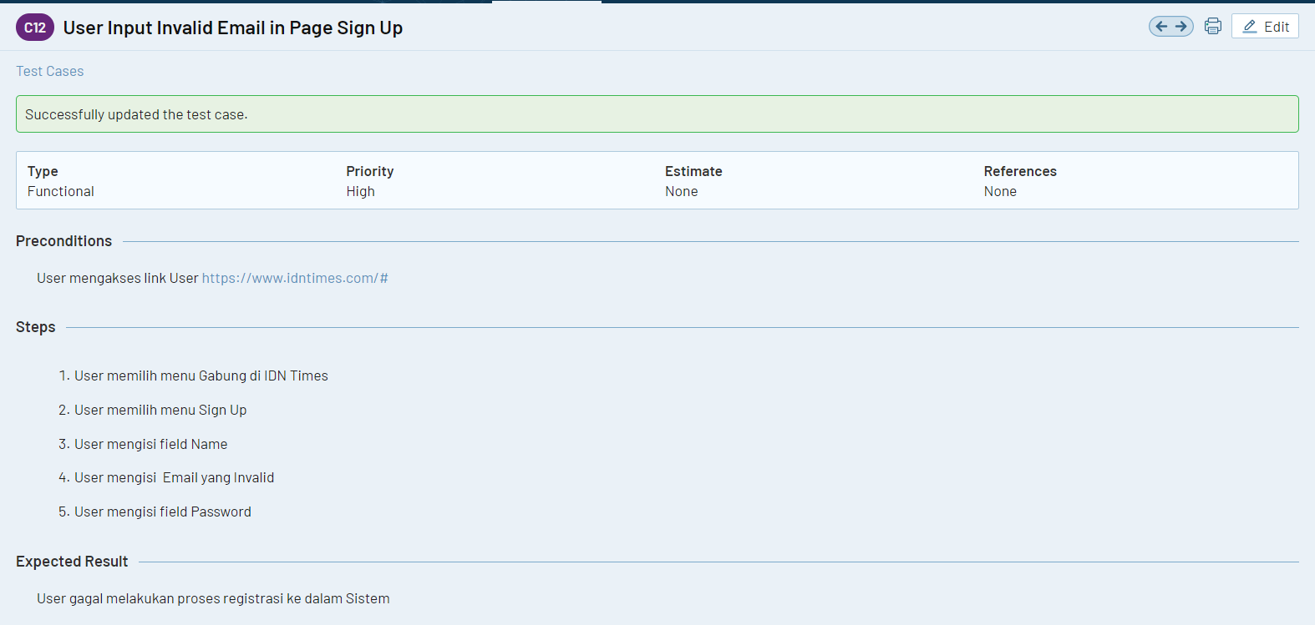

Test Case 3 : User input the same Password and Confirm Password

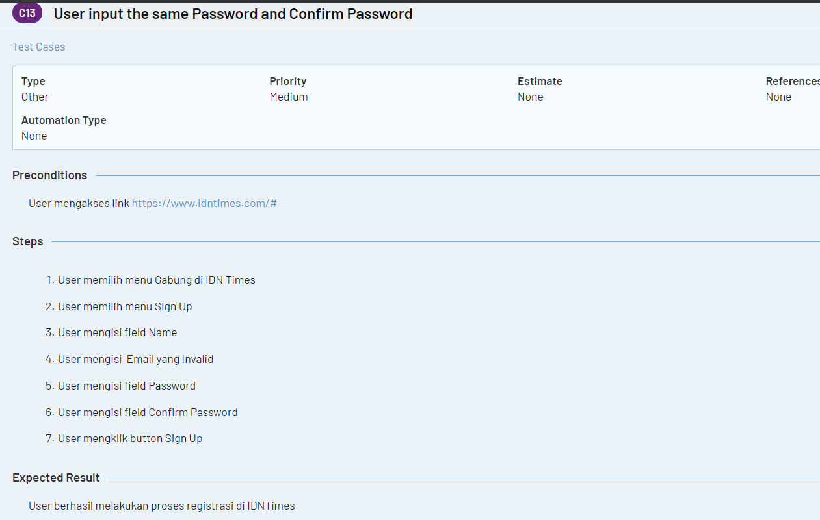

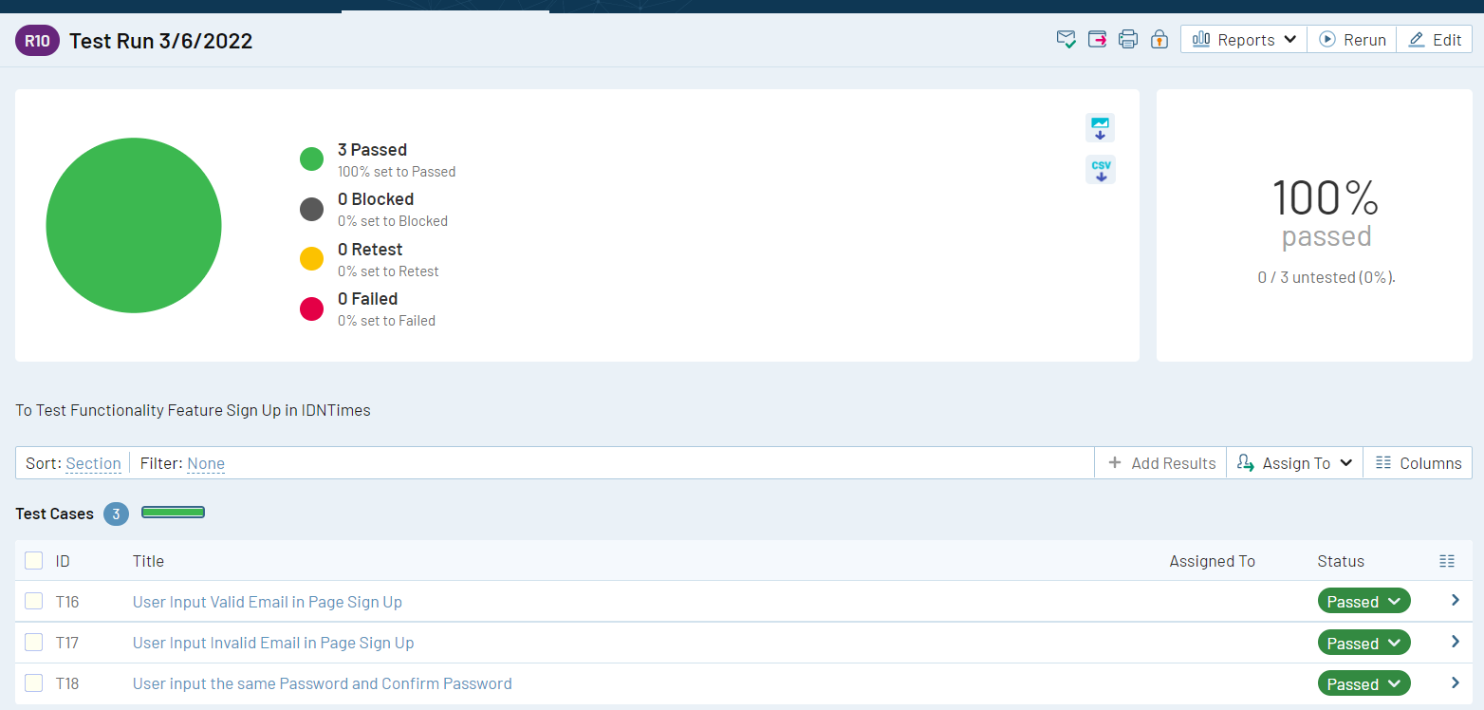

Page Search

Test Case 1 : User Input Text in Menu Search

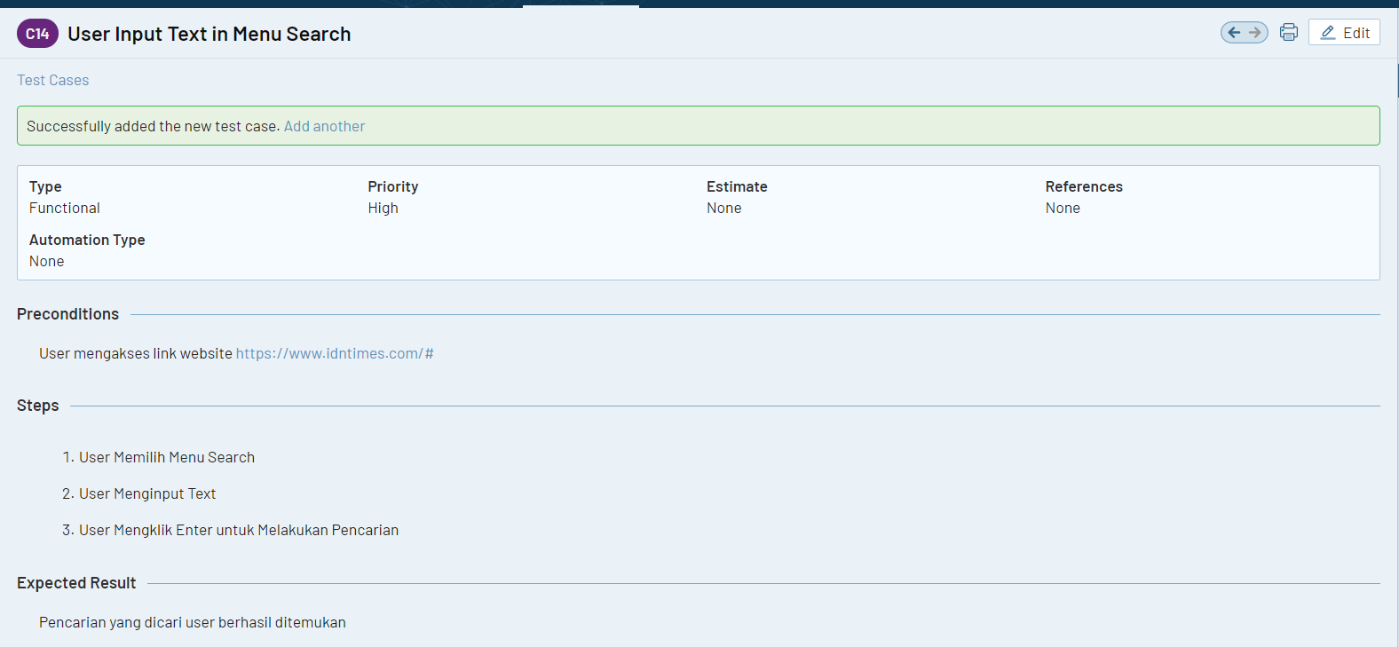

Test Case 2 : User Input Number in Menu Search

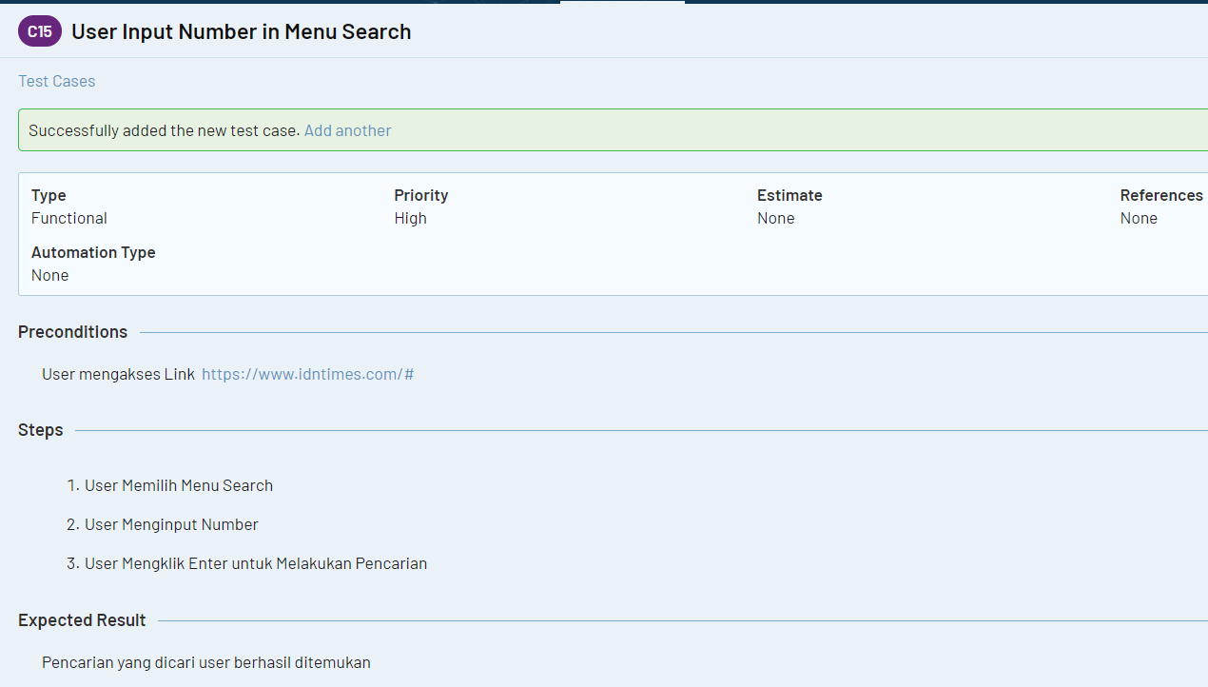

Test Case 3 : User Input Character in Menu Search

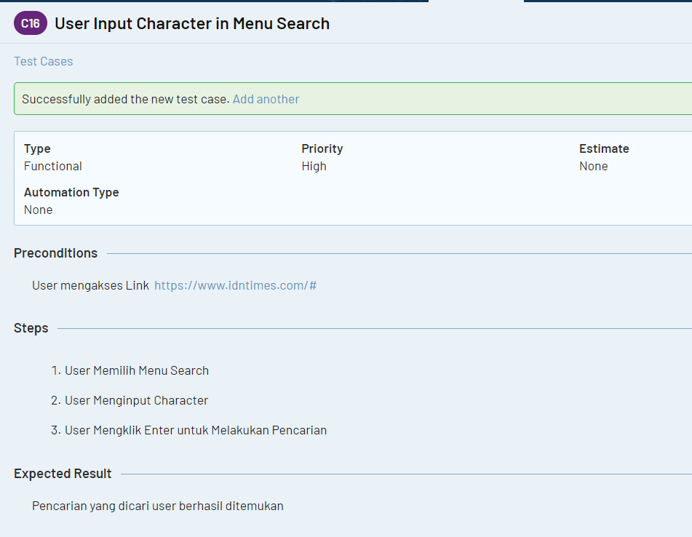

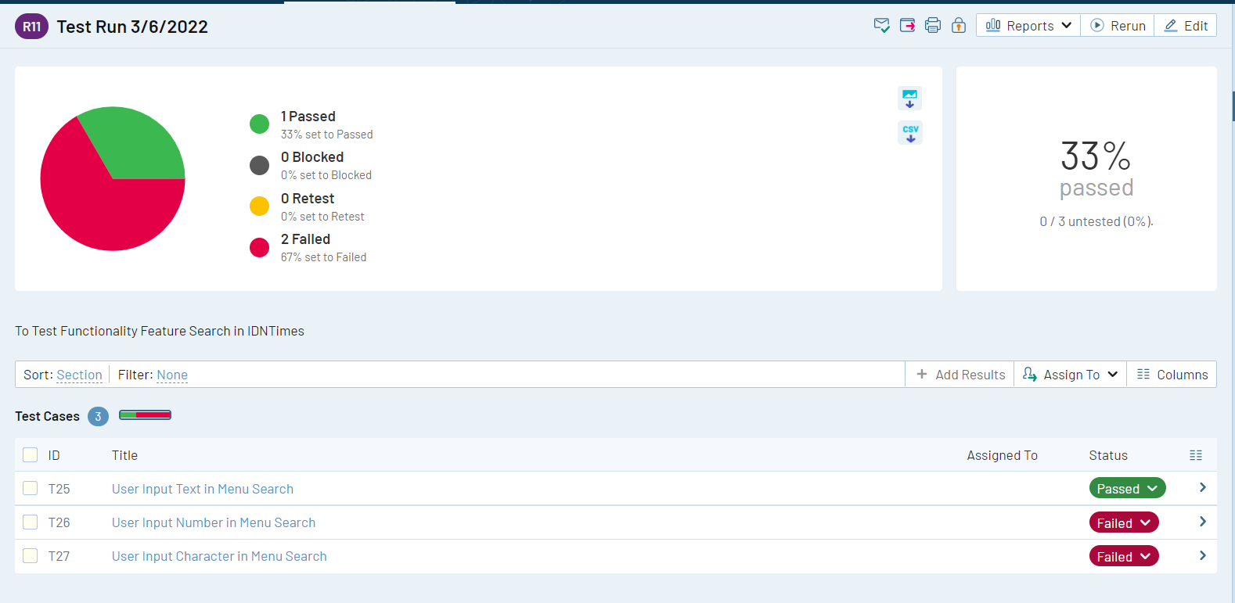

Link Jira : <https://anitalasmariasiagian.atlassian.net/jira/software/projects/BAS/boards/1/roadmap>

Link TestRail : <https://narumondaiii.testrail.io/index.php?/projects/overview/5>

Halaman yang akan diuji adalah : Shopee

1. Test Case untuk Halaman Login

Page Login

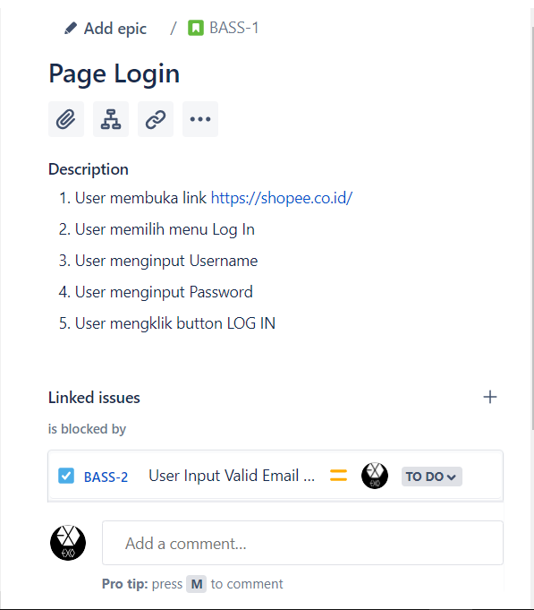

* Test Case 1 : User Input Valid Email and Password

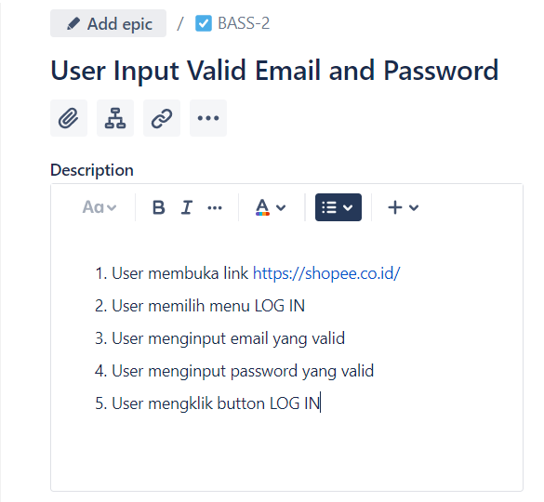

* Test Case 2 : User Input Invalid Email

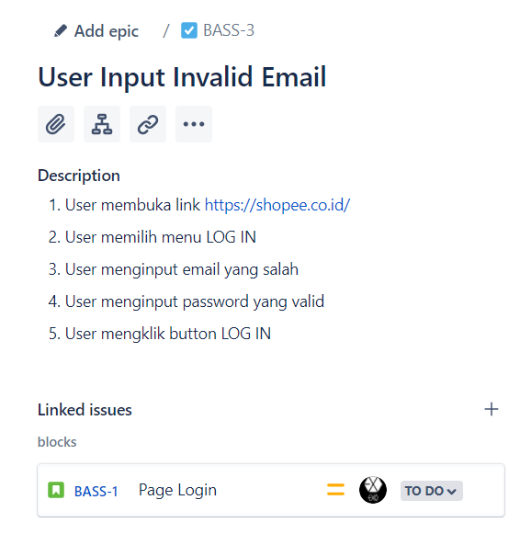

* Test Case 3 : User Input Invalid Password

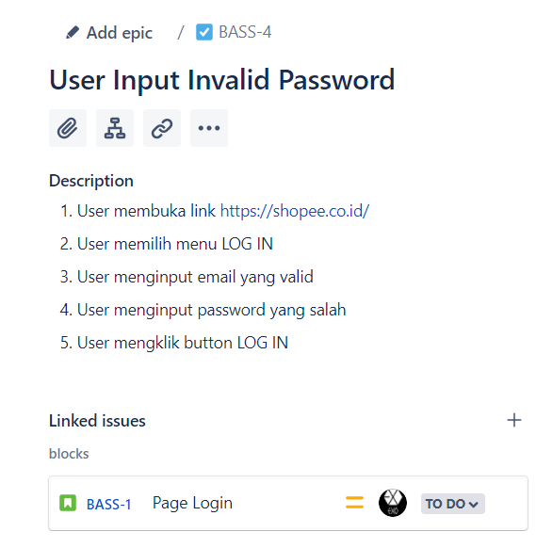

1. Test Case untuk Halaman Registrasi

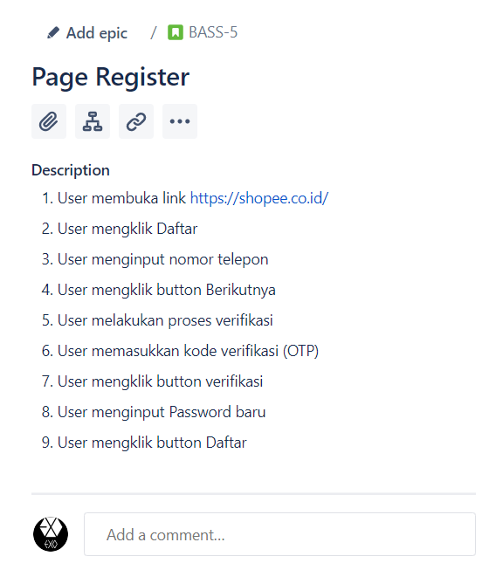

* Test Case 1 : User Input Valid Number Phone

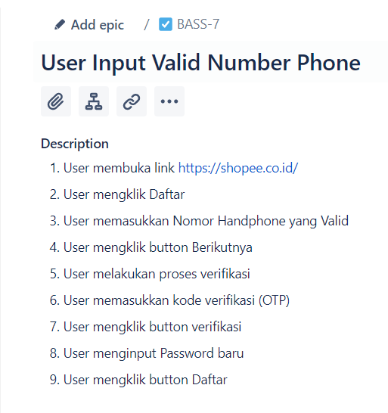

* Test Case 2 : User Input Invalid Number Phone

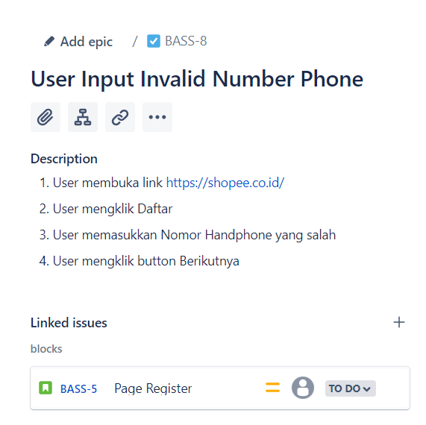

* Test Case 3 : User Input Invalid Kode Verifikasi

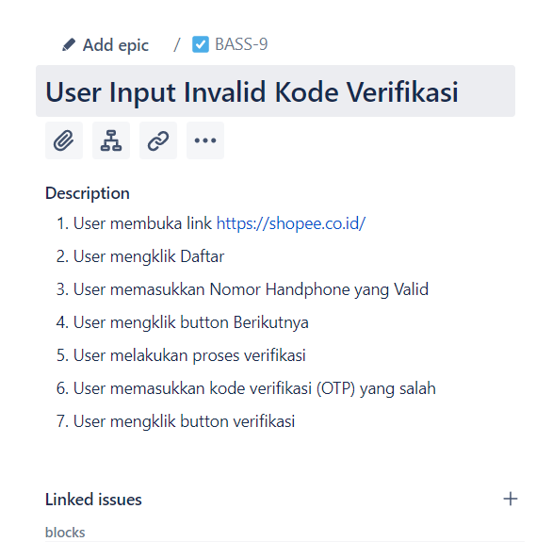

1. Page Butuh Bantuan

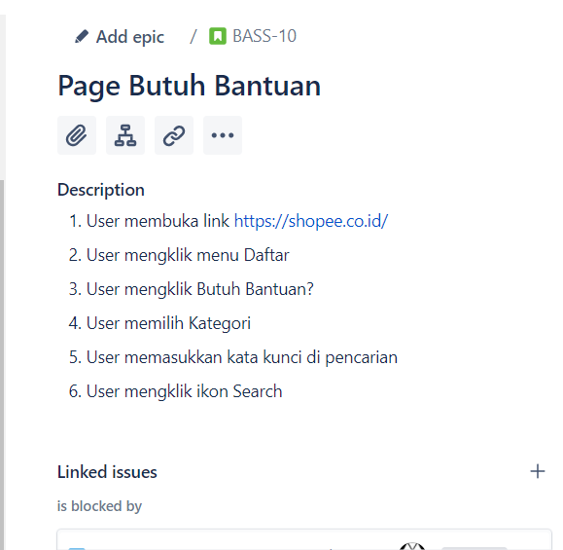

* Test Case 1 : User Input Text in Field Search’

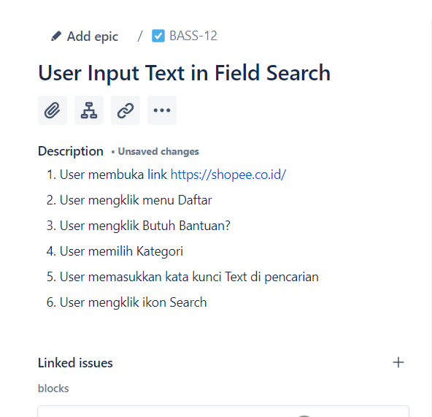

* Test Case 2 : User Input Number in Field Search

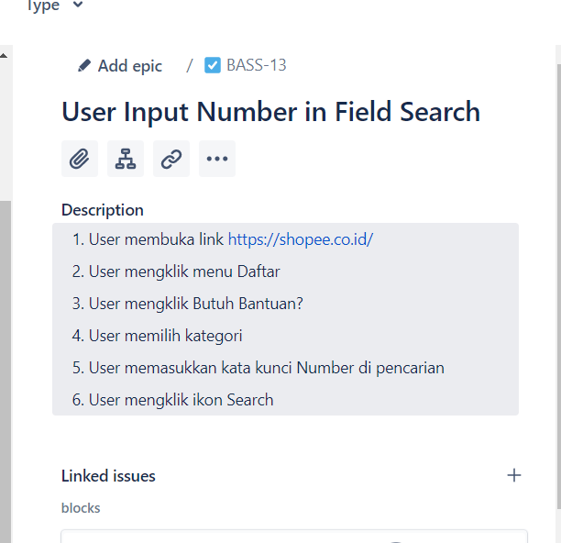

* Test Case 3 : User Input Character in Field Search

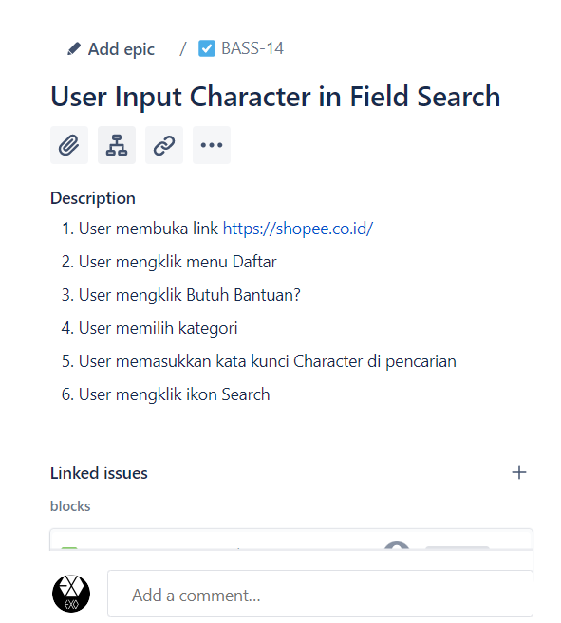

Board BIGTASK1_Anita Siagian_Shopee

TestRail

Page Login :

1. Test Case 1 : User Input Valid Email and Password

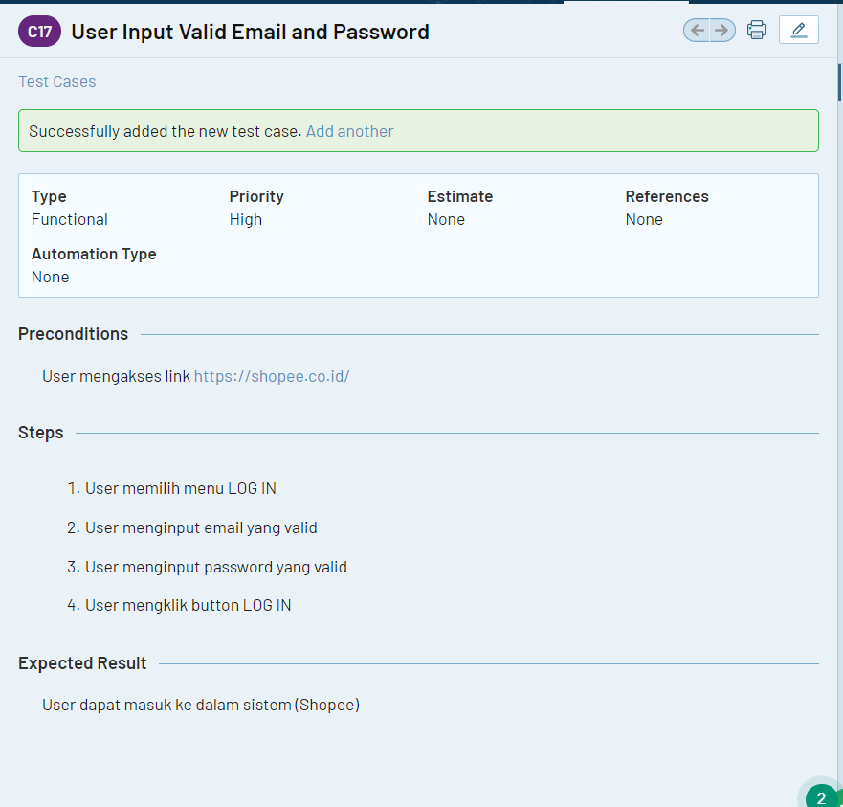

1. Test Case 2 : User Input Invalid Email

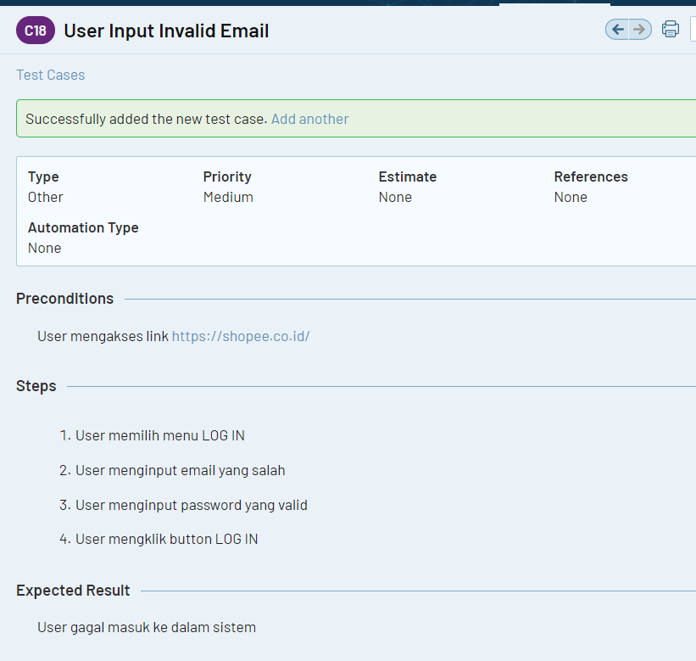

1. Test Case 3 : User Input Invalid Password

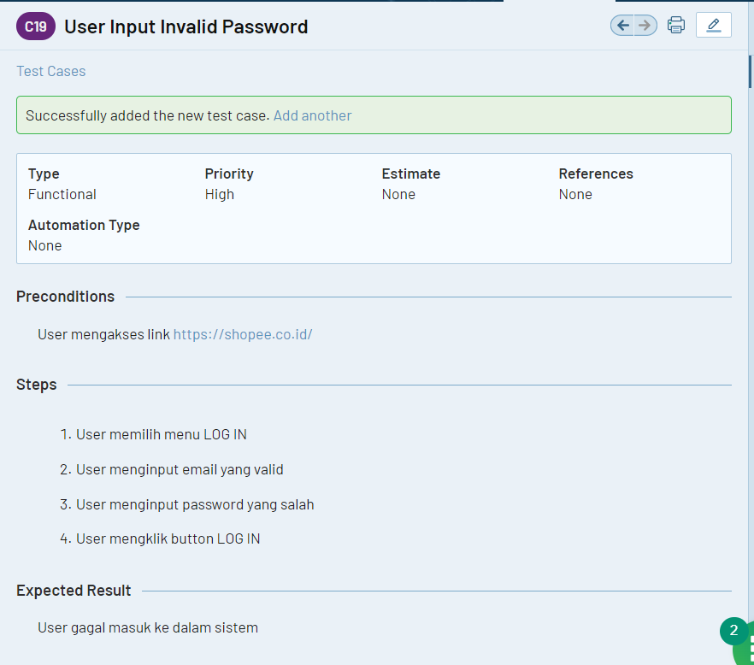

Test Run Login

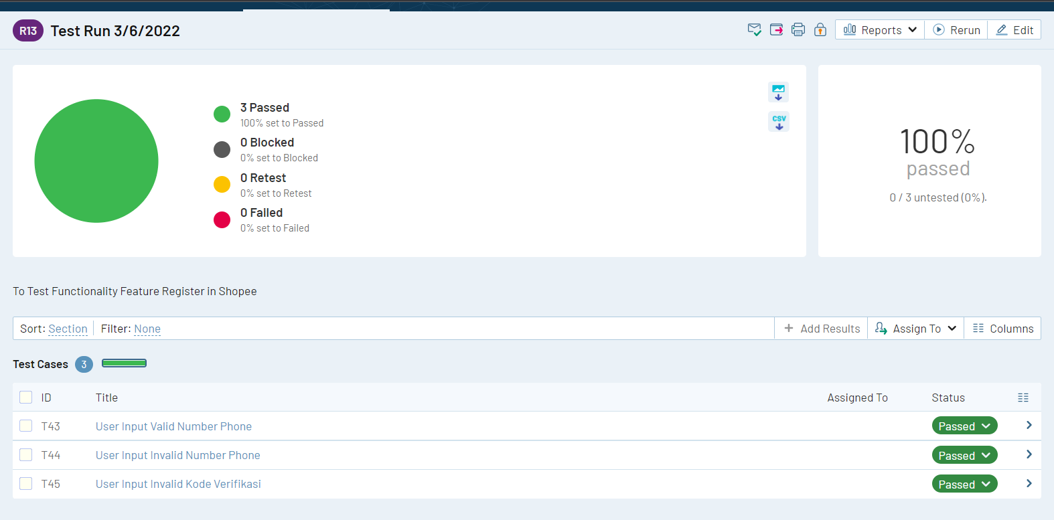

Page Register

1. Test Case 1 : User Input Valid Number Phone

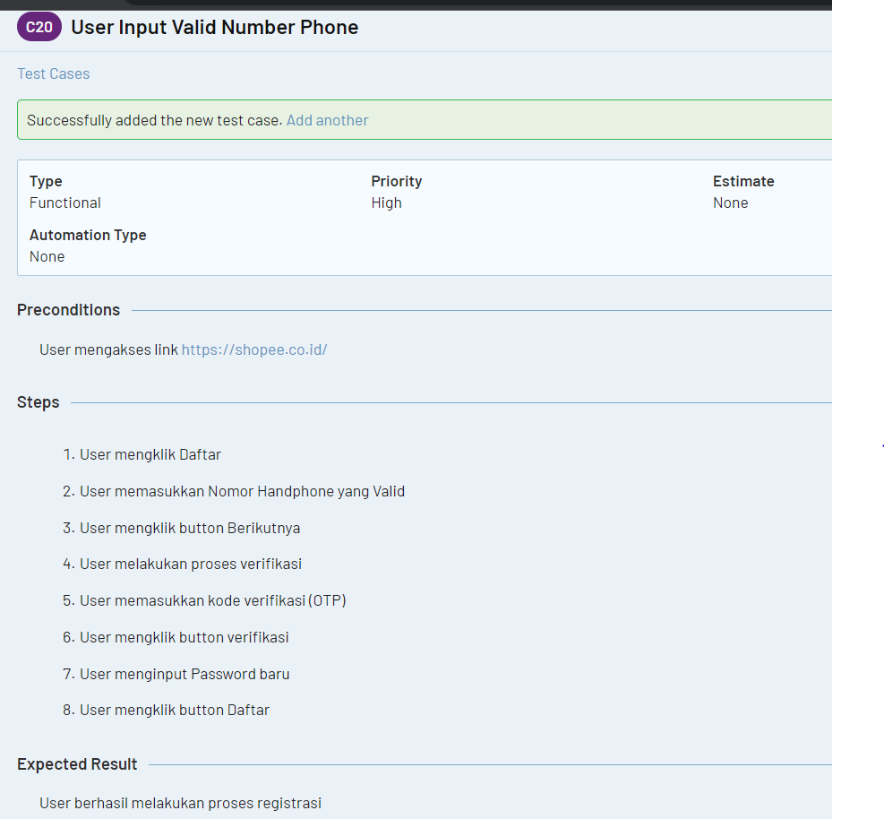

1. Test Case 2 : User Input Invalid Number Phone

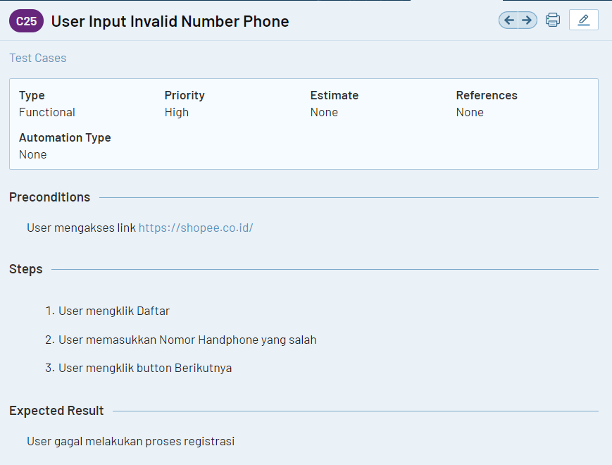

1. Test Case 3 : User Input Invalid Kode Verifikasi

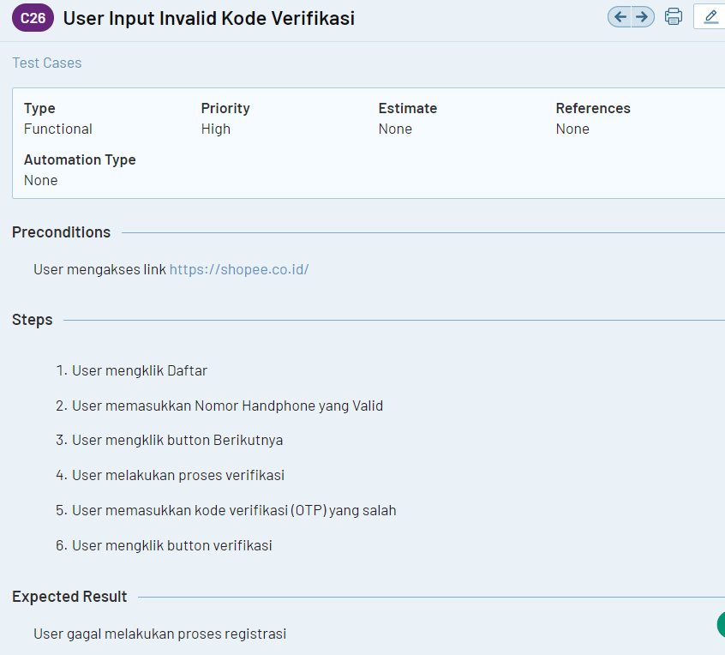

Test Run Register

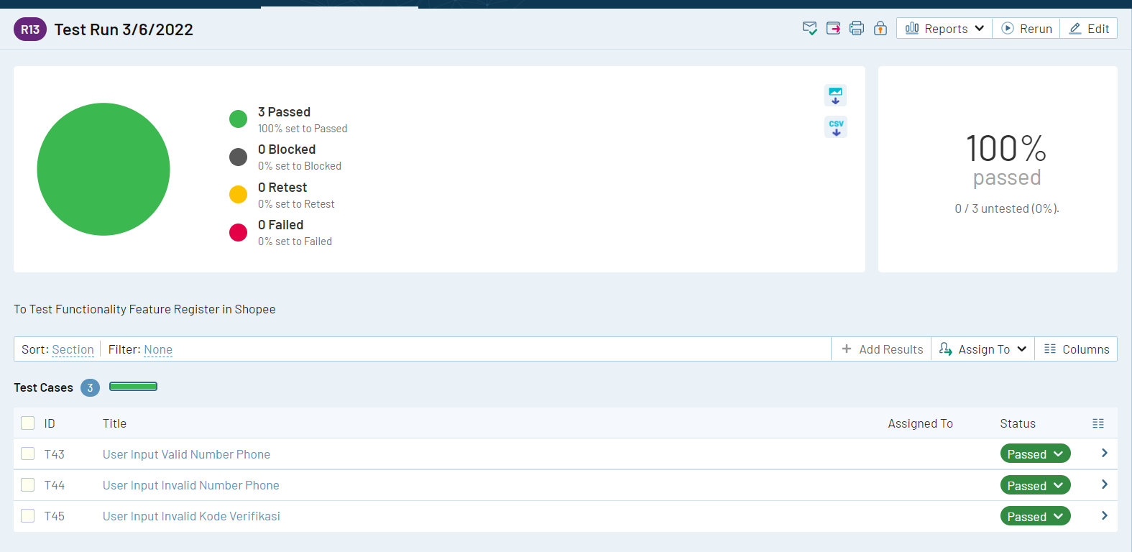

Page Butuh Bantuan

1. Test Case 1 : User Input Text in Field Search

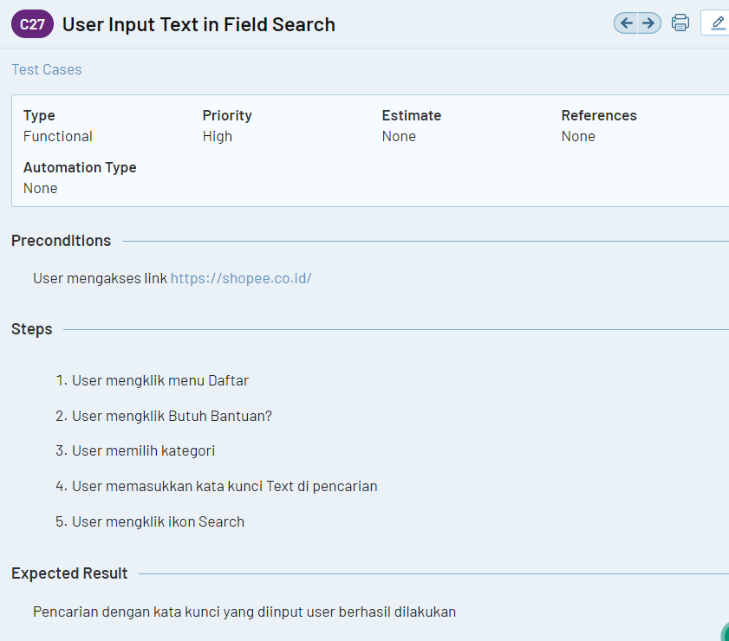

1. Test Case 2 : User Input Number in Field Search

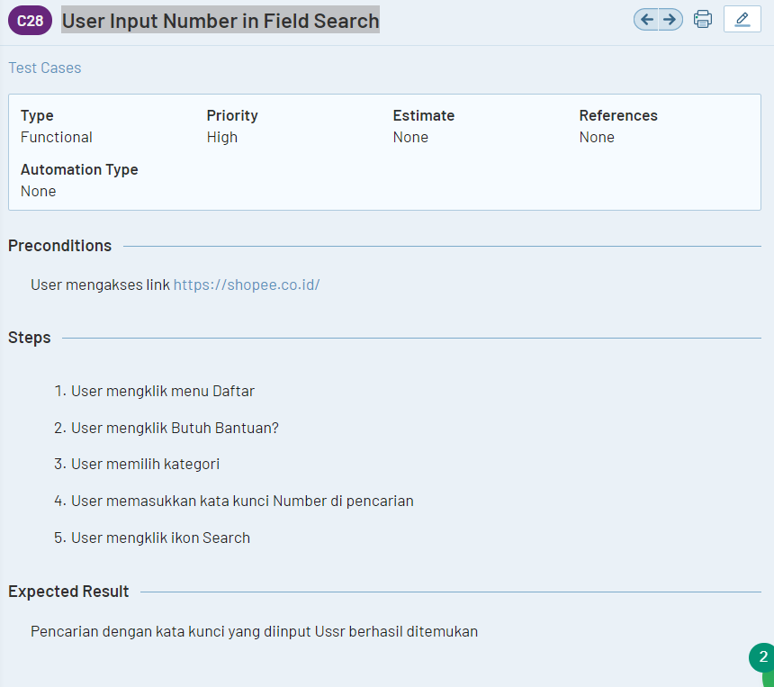

1. Test Case 3 : User Input Character in Field Search

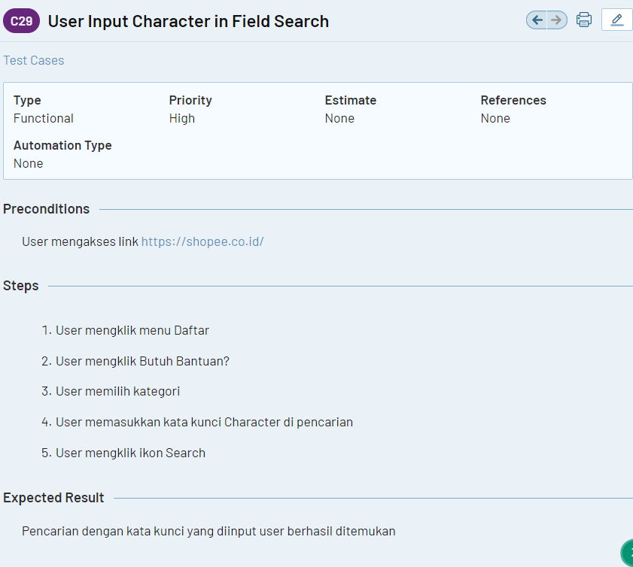

Test Run Butuh Bantuan

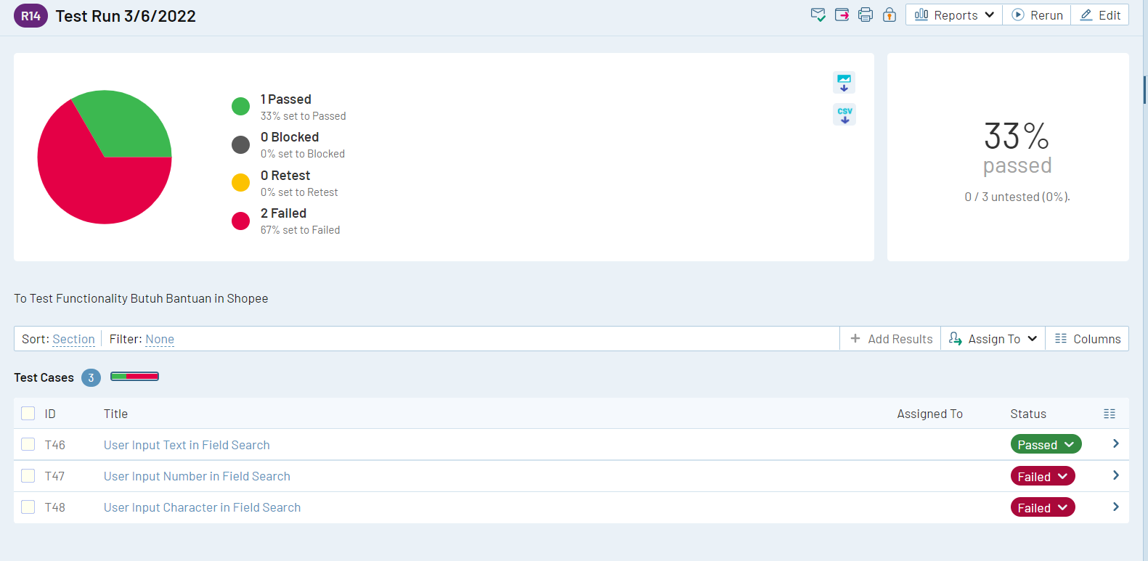

Link TestRail : <https://narumondaiii.testrail.io/index.php?/projects/overview/6>

Link Jira : <https://anitalasmariasiagian.atlassian.net/jira/software/projects/BASS/boards/2/roadmap>